Is cannabis more harmful than alcohol?

Rachel Sandlain

Data Science, University of Maryland Baltimore County

DATA 606: Capstone in Data Science

Professor Barber

December 13, 2022

Abstract

There is increasing interest in legalizing cannabis for medicinal or recreational use or both. Many states are moving forward with various legalization initiatives, but marijuana remains illegal at the federal level. Commonly objections to legalizing marijuana are based in safety concerns. Data from the National Survey on Drug Use and Health was analyzed using Stata to test the claim that cannabis is illegal because it is more dangerous to health and productivity than alcohol. Regression analysis, demographic comparison, and the creation of a naïve use score demonstrate that many people can use and not misuse alcohol, cannabis, or both. When misuse does occur, marijuana is not misused at a higher rate that alcohol. While it might be expected that the COVID-19 Pandemic coincided with increasing rates of use and misuse of alcohol, marijuana, or both, the data does not support this idea. The data suggests that efforts to address the wrongs performed in the name of the ‘War on Drugs’ and overturn racially motivated marijuana prohibitions are not inviting the catastrophic harms to health and productivity feared by some.

Introduction

In recent years, the legalization of cannabis has been a matter of great interest to a variety of people. More and more states are moving to legalize cannabis, but it remains illegal at the federal level (Brenan, 2020). This has caused a variety of problems, such as banking for cannabis businesses, but also for federal employees (Berke, Gal, & Lee, 2022). To date 21 states have legalized cannabis, meaning the majority of Americans have legal access to cannabis in some form (Berke, Gal, & Lee, 2022). Even if a federal employee, including an active-duty service member, lives in a state that allows cannabis use, they cannot use it, without endangering their job, because federally cannabis is an illegal Schedule I drug (Berke, Gal, & Lee, 2022). The federal government employs about 6% of the work force, meaning millions of Americans are facing contradictory policies (Hill, 2020). This issue hits close to home – Maryland recently voted to legalize recreational cannabis and 18% of Maryland’s workforce worked for federal, state, or local government in 2019 (Elwood, 2022) (Maryland State Archives, 2021).

While more Americans than ever support legalization, many still do not (Brenan, 2020). Many object to legalizing cannabis on safety grounds, claiming that cannabis is a Schedule I drug because it is more dangerous than alcohol or tobacco (Svrakic, et al., 2012). The National Survey on Drug Use and Health (NSDUH) has data on both the frequency and recency of alcohol and marijuana use, on substance dependence, and asks questions on employment, income, and poverty.

If marijuana is indeed more dangerous, one would expect to see more difficulty limiting use, more experiences of withdrawal symptoms, and more use despite problems among marijuana users than alcohol users, perhaps without even adjusting for the number of users. If marijuana is more dangerous to society than alcohol, marijuana users would be more likely to be unemployed, experience poverty, and have less income than alcohol users.

## Context

## Early twentieth century efforts to criminalize recreational cannabis use and eliminate the use of medical cannabis were rooted in racism as the majority of people using marijuana recreationally were Mexican American or African American (Grossman, 2019). Cannabis was demonized as a “promoter of violence, crime, sexual depravity, and insanity, particularly in minority communities” in an “explicitly racist crusade” conducted by the first Commissioner of the Federal Bureau of Narcotics (Grossman, 2019). Congress attempted to regulate and tax marijuana out of existence by passing the Marihuanna Tax Act in 1937 (Grossman, 2019). Although medical marijuana was not targeted, pharmacists and physicians both warned that these taxes and regulations could eliminate medical “marijuana production—an unacceptable result, because ‘future investigation may show that there are substantial medical uses for cannabis’” (Grossman, 2019). Many of these “future investigations” were never conducted, “in large part because scientists interested in studying the medical effects of cannabis [face] numerous regulatory hurdles” (Grossman, 2019). The investigations that were conducted led an Administrative Law Judge, asked by the DEA to study the issue in 1988, to recommend marijuana be rescheduled (Grossman, 2019). The Judge stated that marijuana should be a Schedule II drug because there was both “currently accepted medical use” and “that ‘[m]arijuana, in its natural form, is one of the safest therapeutically active substances known to man,’ and that many physicians recognized its safety” (Grossman, 2019). The DEA rejected this recommendation in 1989 (Grossman, 2019).

## While marijuana as medicine fell out of favor in the 1940’s, it became increasingly popular as a recreational intoxicant, particularly with beatniks and hippies in the 50’s and 60’s (Grossman, 2019). President Nixon, who identified cannabis with leftist culture and crime, targeted marijuana in his “War on Drugs” (Grossman, 2019). The current schedule system for classifying drugs, created by the Controlled Substances Act of 1970, was one of the first shots fired in the war on drugs (Grossman, 2019).

Today many advocate for comprehensive legal reform of cannabis policy, at least in part, as an effort to redress the harm done by racial discrimination in the enforcement of drug laws and the devastating consequences of cannabis prosecutions within the black community (Grossman, 2019). The war on drugs caused such devastation in African American communities that Michelle Alexander calls these policies “The New Jim Crow” (Grossman, 2019). Some object to marijuana being legal for only medical purposes because this policy would allow for “discriminatory prosecution of people of color” (Grossman, 2019).

## Methods

As a Schedule I drug, there are no accepted medical uses and a high potential for abuse of cannabis (Svrakic, et al., 2012). In contrast, alcohol is unscheduled. This suggests that cannabis is more harmful than alcohol. If cannabis is more harmful than alcohol, one would expect to see a larger adverse effect of use on health and productivity. This leads to the research question of this study: Does cannabis have the same impact on health and productivity as alcohol?

Analysis was performed using Stata/MP16.1 and the 2017, 2019, and 2020 public use data sets from the National Survey on Drug Use and Health. This analysis builds on a project conducted in PUBL 607: Statistical Applications in Evaluation Research. In order to compare those who used cannabis or alcohol and those who did not, a user was defined as anyone who had used (either alcohol or cannabis) during the last 12 months. If someone used both alcohol and marijuana, they were considered a marijuana user. While misuse or abuse of any substance is a complicated issue, for the purposes of this analysis a very simple "abuse score" was created by aggregating "yes" responses to questions such as "Have you tried to limit your use? Were you successful?" "Have you experienced withdrawal symptoms?" and "Have you continued to use despite problems?"

A comparison of the demographics of nonusers, alcohol users, and marijuana users was performed. Demographic categories included sex, race group, if the respondent identified as LGBT, marital status, self-reported health status of the respondent, English fluency of the respondent, college graduation, military service, and if the respondent had work outside the home in the last two weeks.

Regression analysis was also performed in an attempt to answer the following questions:

* Is there a (strong) correlation between the demographics and use of alcohol, marijuana, or neither?
* Is there a (strong) correlation between the demographics and abuse score?
* Is there a (strong) correlation between the demographics and the (individual) abuse outcomes?

Abuse outcomes were items such as continuing to use despite emotional problems, needing to use more of drug to achieve same effect, and experience of withdrawal symptoms. Analysis focused on those 18-65 years of age as users and nonusers were more comparable, especially in terms of employment.

## Alcohol Use

People who drink alcohol are probably unmarried, heterosexual, healthy, speak English very well, have at least some college education, have not served in the military, earn $50,000 or more annually, and work outside the home. Most alcohol users do not have a problem with alcohol. More than 75% of respondents "yes" to at most two alcohol misuse questions. Only 10% of respondents said "yes" to four or more alcohol misuse questions. The maximum alcohol use score was 17. Figure 1 below shows only alcohol users who answered "yes" to at least one alcohol misuse question.

**Figure 1**

*Histogram of nonzero alcohol use score for respondents aged 18-65*



Of all the alcohol use outcomes, trying to set limits around drinking, trying to cut down on drinking, and spending a lot of time drinking were most strongly correlated with the demographic data.

## Marijuana Use

People who use marijuana are most likely unmarried, heterosexual, healthy, speak English very well, have at least some college education, have not served in the military, earn $50,000 or more annually, and work outside the home. Most marijuana users do not have a problem with marijuana. In fact, nearly 90% of respondents replied "no" to all marijuana misuse questions. The maximum marijuana use score was 17. Figure 2 below shows only marijuana users who answered "yes" to at least one misuse question.

**Figure 2**

*Histogram of nonzero marijuana use score for respondents aged 18-65*



Similar to alcohol use, the abuse outcomes most strongly correlated with demographic variables are spending a lot of time getting or using marijuana and trying to set limits on use. Needing to use more marijuana to get the same effect and trying to cut down on use were also strongly correlated with demographic data.

## Combined Misuse

Even when combining alcohol and marijuana use, most people do not have a misuse problem. More than 75% of respondents said "yes" to at most three alcohol or marijuana misuse questions. Only 10% of respondents said "yes" to five or more misuse questions. The maximum combined use score was 30. Figure 3 below shows only users who answered "yes" to at least one misuse question.

**Figure 3**

*Histogram of combined nonzero alcohol and marijuana use score for respondents aged 18-65*

## Pandemic Impact

One of many impacts of the COVID-19 pandemic is the potential change in substance use patterns. One might instinctively suspect to find more people using and misusing alcohol or marijuana as a result of the pandemic, but does the data reflect this?

The pandemic changed how data for the NSDUH was collected. The authors caution against directly comparing data from 2020 to another year because the impact of the change in collection method on respondents is unknown (SAMHSA, n.d.).

**Figure 4**

*Bar graph showing percent change in population proportion for respondents aged 18-65*

While there is a marked increase in marijuana users from 2017 to 2019 (perhaps in response to growing legalization efforts), there is little change in the proportions of the population who use alcohol and marijuana from 2019 to 2020, shown in red in Figure 4 above.

**Figure 5**

*Bar graph showing percent change in population proportion for respondents aged 18-65 who misuse alcohol or marijuana*

One might expect that more people who use either marijuana or alcohol might begin to misuse during the pandemic. The changes in population proportion among the upper quartile of misuse responses reflect the changes in the proportion of people who use are show in in Figure 5 above. The changes from 2019 to 2020, shown in red, are relatively flat and do not reflect what one might expect.

**Figure 6**

*Bar graph showing percent change in demographic categories for respondents aged 18-65 who misuse alcohol*

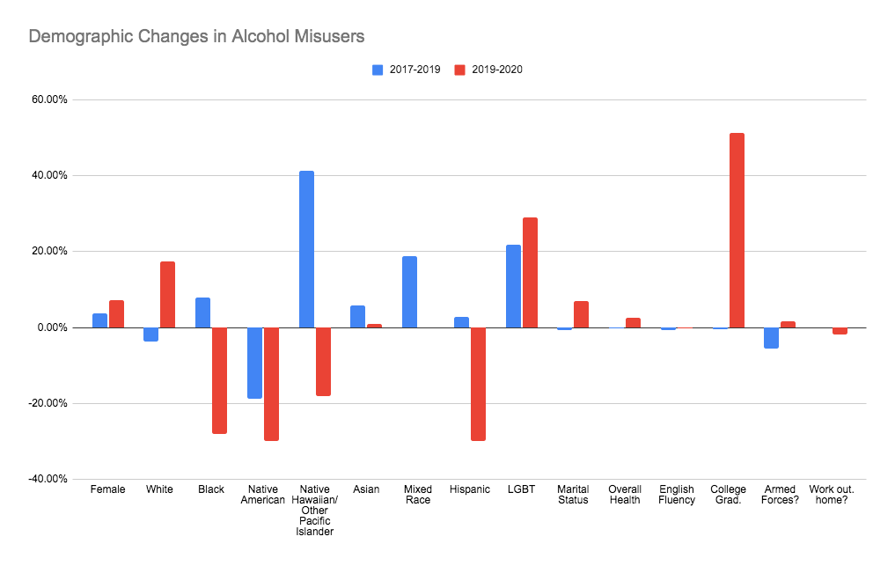

Among alcohol misusers, that is the 25% of those who reply "yes" to alcohol misuse questions most often, there does not appear to be a clear trend in demographic changes overtime, as shown in Figure 6 above. It is interesting to see the sharp increase in college graduates from 2019 to 2020. In both 2017 to 2019 and 2019 to 2020 there was a marked decrease in Native American and Alaskan Native respondents who misused alcohol. There are many possible contributing factors to these changes, more analysis and likely more data would be needed to attempt to identify causes.

**Figure 7**

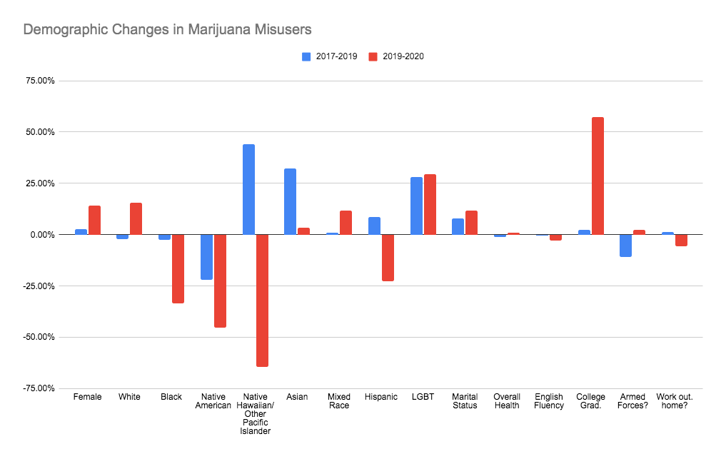*Bar graph showing percent change in demographic categories for respondents aged 18-65 who misuse marijuana*

Similar demographic change data among the 25% of respondents who replied "yes" to marijuana misuse questions most often, marijuana misusers, is displayed in Figure 7 above. Again, changes from 2019 to 2020 are shown in red. While there does not seem to be an overarching trend, it is interesting to note similarities between the alcohol misuse and marijuana misuse. There is a similar sharp increase among college graduates from 2019 to 2020, a similar marked decrease among Native American and Native Alaskan respondents over both time periods. There is even a similar increase among LGBT identifying respondents in both time periods for both marijuana and alcohol misusers.

## Discussion and Policy Implications

This data shows that most people who use alcohol or marijuana or both, do not report having problems related to their use. In fact, the majority of respondents (64%) report no problems at all. Those who do report problems are likely male, white, healthy, and employed, at least part time, outside the home. One does not see the dangerous impact to health and productivity in marijuana users asserted by many, even those who report problems with their marijuana use.

This data suggests that states like Maryland are not courting certain peril by legalizing cannabis. While there is risk associated with using any substance, the data does not support the claim that all marijuana users are poor, unhealthy, unemployed burdens to society. Marijuana does not appear, at least in this data, to be any riskier than alcohol.

When problems related to use of alcohol or marijuana arise, the emerging themes seem to be that people who identify as LGBT, people who are unmarried, and men are more likely to be impacted. Perhaps members of these groups are more likely to develop a use related problem when or if they being to use. It is possible members of these groups are self-medicating in an attempt to treat some underlying problem, perhaps loneliness. Even before the pandemic, men, unmarried individuals, and members of the LGBT community may have felt isolated by circumstance and turned to alcohol or marijuana, just as was expected during the pandemic. More investigation is needed in this area.

Programs to support users in addressing misuse of alcohol and marijuana should consider how they can address the root causes of misuse and support communities more impacted by misuse. Perhaps programming should focus on helping people to build support systems outside of marriage that do not involve the use of marijuana or alcohol. Programming also needs to be mindful that most of the people who may need their services work - it may be wise to focus on evening and weekend hours instead of “normal business hours.”

## Conclusion

## Drug use and misuse is complicated. For most people, use of alcohol or marijuana is not problematic. In fact, most people who use either cannabis or alcohol remain healthy and employed. When people have problems related to use of alcohol or cannabis problems occur at similar rates. This data does not seem to support the assertion that marijuana is illegal because it is ‘more dangerous’ than alcohol.

As legalization becomes more widespread, care needs to be taken to ensure policy and programming to address misuse supports the people who need help, not the people who are expected or assumed to have a problem. With more research, society can hopefully predict the types of people who will likely have an abuse problem so interventions can be more targeted and hopefully more effective.

Acknowledgements

This project began as a class project in Spring 2021 PUBL 607: Statistical Applications in Evaluation Research. I would like to thank my classmates and professor for their advice, feedback, data cleaning assistance, and code review on the earliest versions of this project. Thank you Ringoir, Tanguy, Salizzoni, Andi, Seyedi, Khabbaz, Shadi, Filosa, Jen and especially Dr. Zoë McLaren for all your help and advice.

# Works Cited

Berke, J., Gal, S., & Lee, Y. J. (2022, November 9). *Business Insider*. Retrieved from 2 new states voted to legalize marijuana in the 2022 elections. See a list of every state where cannabis is legal.: https://www.businessinsider.com/legal-marijuana-states-2018-1?r=US&IR=T

Brenan, M. (2020, November 9). *Gallup*. Retrieved from Support for Legal Marijuana Inches Up to New High of 68%: https://news.gallup.com/poll/323582/support-legal-marijuana-inches-new-high.aspx

Elwood, K. (2022, November 9). Maryland legalized recreational marijuana. Here’s what you should know. *The Washington Post*.

Grossman, L. A. (2019). Life, Liberty, [and the Pursuit of Happiness]: Medical Marijuana Regulation in Historical Context . *Food and Drug Law Journal*, 280-321.

Hill, F. (2020, May 27). *Brookings*. Retrieved from Public service and the federal government: https://www.brookings.edu/policy2020/votervital/public-service-and-the-federal-government/

Maryland State Archives. (2021, April 1). *Maryland at a Glance Workforce*. Retrieved from Maryland Manual On-Line: https://msa.maryland.gov/msa/mdmanual/01glance/economy/html/labor.html

SAMHSA. (n.d.). *2020 National Survey of Drug Use and Health (NSDUH) Releases*. Retrieved from SAMHSA Substance Abuse and Mental Health Services Administration: https://www.samhsa.gov/data/release/2020-national-survey-drug-use-and-health-nsduh-releases

Svrakic, D. M., Lustman, P. J., Mallya, A., Lynn, T. A., Finney, R., & Svrakic, N. M. (2012). Legalization, Decriminalization & Medicinal Use of Cannabis: A Scientific and Public Health Perspective. *Missouri Medicine*, 90-98.